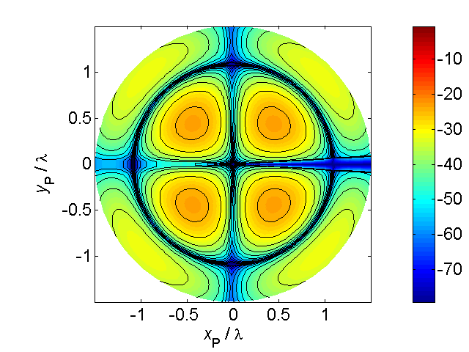

[**HSC PHYSICS ONLINE**](http://www.physics.usyd.edu.au/teach_res/hsp/sp/spHome.htm)

**WAVES**

**RAY MODEL OF LIGHT**

**REFLECTION and REFRACTION**

**DISPERSION**

**IMAGE FORMATION: MIRRORS and LENSES**

A great deal of evidence suggests that light is a wave and under a wide range of circumstances, light travels in a straight line. For example, sunlight casts sharp shadows. Another example is **refraction** where light passes from one transparent medium into another (figure 1). Such observations, has led to the **ray model of light**. A **ray** is an idealization that represents an extremely narrow beam of light.

According to the ray model, we see an object because light reaches our eyes from each point on the object. Although the light leaves a point on the object in all directions, only a small bundle enters your eye. The ray model of light has been very successful in explaining many aspects of the behaviour of light such as reflection, refraction, dispersion, and the formation of images by mirrors and lenses.

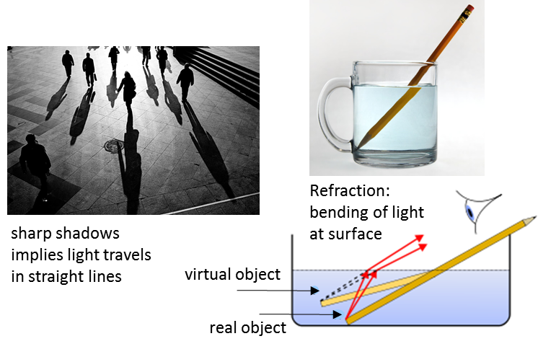

Fig. 1. We can use a ray model to explain the straight line propagation of light. How do we see? A small bundle of light rays come from each single point on an object and enters your eye. A pencil in water looks bent even when it isn’t.

When a ray of light of is obliquely incident upon a medium of different refractive index, the ray is bent. The relationship between the angle of incidence and angle of refraction is described by **Snell’s Law**

(1) 

Refraction is responsible for several common optical illusions.

When you look into a lake and see a fish – where is the fish located?

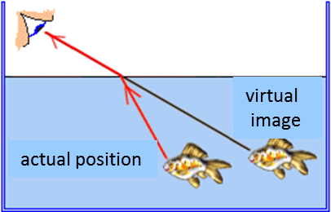

Fig. 2. Where is the fish located?

|  |
| --- |
| **Thinking Exercise**  When you watch a person standing in waist-deep water, it appears that their legs are shorter. Explain this observation using a scientific annotated ray diagram. |

Figure 3 shows a ray of light that emerges from a rectangular slab of glass such that the direction of the beam of light is unchanged.

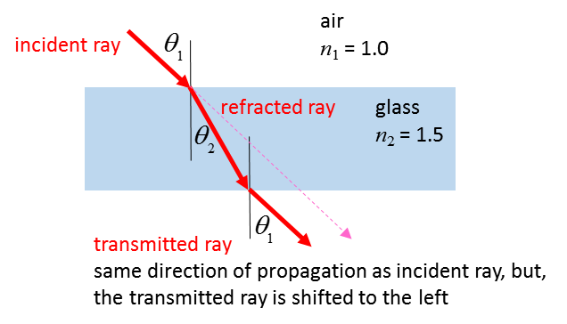

Fig. 3. Light passing through a glass slab.

**Why does a diamond sparkle?**

The refractive index of glass is 1.5 whereas for diamond it is 2.42. The critical angle for glass is 41o and the critical angle for diamond is 24.4o which is smaller than for any other common substances. (Check the calculations for the critical angles for diamond and glass). When light enters a cut diamond, the large refractive index compare with air results in the strong dispersion of the light and this dispersed light is mostly incident on the sloping backsides of the gem at angles greater than 24.4o, hence most of the light is totally internally reflected. Further dispersion occurs as the light exists through the many facets of its face. Hence, we see flashes of a wide range of colours, but with only one eye are they noticeable at any one time – these narrow flashes are what makes diamond “sparkle”.

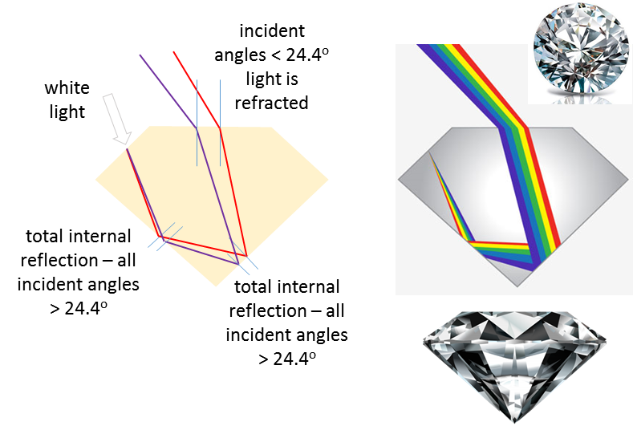

**Why do we see the Sun after it has set?**

Because of refraction, when the Sun is near the horizon, it appears higher in the sky than it actually is. So, if you watch a sunset, we see the Sun for several minutes after it has sunk below the horizon and thus, slightly more daylight each day. The Earth’s atmosphere is more dense towards the ground and light travels faster in the thinner atmosphere further from the ground, so the light from the sun does not travel in a straight line, but travels in longer and higher path in penetrating the atmosphere. Since the density of the atmosphere changes gradually, the light also bends gradually to propagate in a curved path. When the Sun (Moon) is near the horizon, the rays from the lower edge are bent more than the rays from the top edge – this produces a reduction in the vertical diameter causing the Sun (Moon) to appear flatten like a pumpkin.

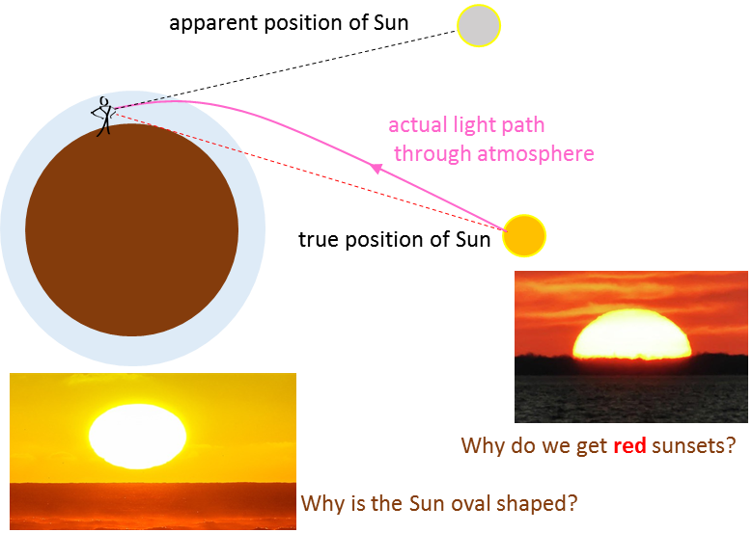

**MIRAGES**

A mirage is an optical phenomenon that creates the illusion of water or an inverted reflection and results from the refraction of light through a non-uniform medium.

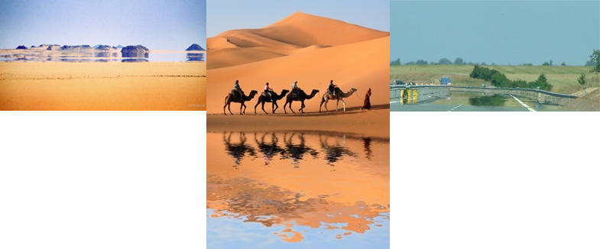

You may see a mirage when driving along a hot road – the distant road appears to be wet, yet it is dry. Why?

The air near the surface of the road is hot and much cooler above. Light travels faster through the thin hotter air then it does through the denser and more cooler air. So, instead of the light travelling in a straight line, it travels in a curved line – the wetness on the road we observe is a reflection of the sky. The bending of light is simply refraction and is a consequence of light having different speeds in different media.

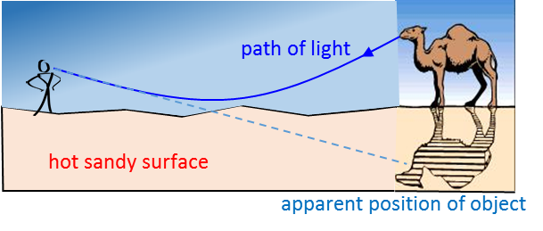

**VISIBLE SPECTRUM and DISPERSION**

Visible light is part electromagnetic spectrum to which our eyes are sensitive and falls within the range of wavelengths from ~ 400 nm to ~ 750 nm. The colour of light is related to its wavelength (or frequency).

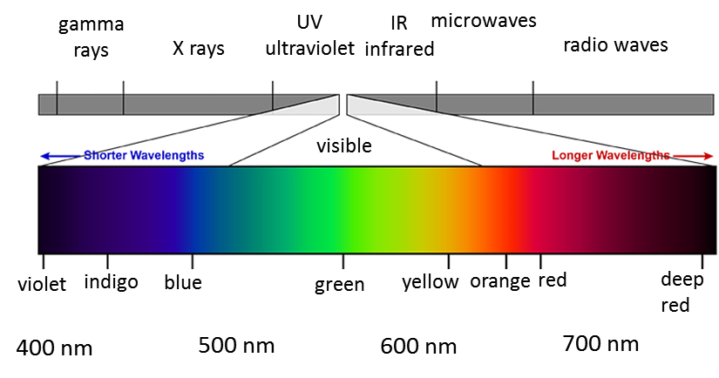

Fig. 4. Electromagnetic spectrum.

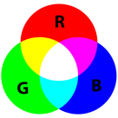

There is no “white” light. When different colours (fixed wavelengths) are mixed together in certain combinations, our eye perceives the light to be white.

A glass prism separates “white” light into a rainbow of colours. This occurs because the index of refraction of a material depends upon the wavelength of the light – the shorter the wavelength, the higher the refractive index.

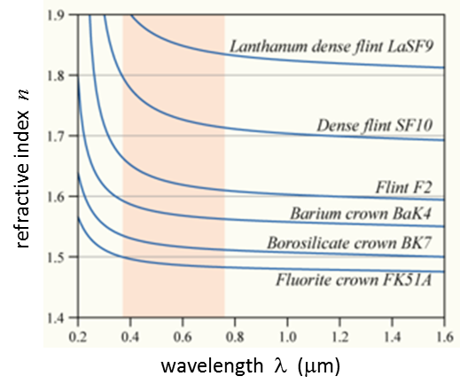

Fig. 5. Index of refraction as a function of wavelength for some transparent solids. N.B. the shorter the wavelength, the higher the refractive index.

White light is a mixture of all the visible wavelengths, so when the white light enters the glass prism, different wavelengths (colours) will be bent through different angles (refraction). Because violet light is bent the most and red light the least, the white light is separated into its component colours and this phenomenon is called **dispersion**.

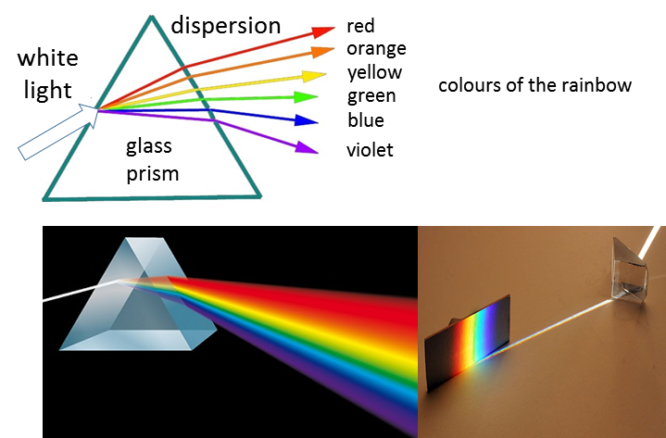

Fig. 6. White light dispersed by a glass prism into the visible spectrum.

Rainbows are a spectacular example of dispersion caused by reflection and refraction from droplets of water. You observe a rainbow by looking at falling water drops with the Sun at your back. The red light is bent the least and is observed higher in the sky, whereas violet light is bent the most and is observed lower in the sky.

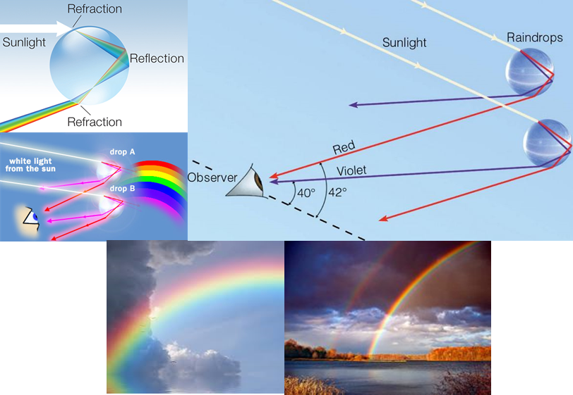

Fig. 7. Rainbows are formed by reflection and refraction of sunlight from falling water droplets.

**REFLECTION and IMAGE FORMATION by a PLANE MIRROR**

For shiny surfaces, such as mirrors, more than 95% of the light may be reflected. When a narrow beam of light falls on a flat surface, the law of reflection is obeyed

angle of incidence = angle of reflection

This is known as **secular reflection**.

When light is incident on a rough surface (even microscopically rough such as paper), the light is reflected in many directions, but at each small section of the surface the law of reflection holds. This is called **diffuse reflection**. Because of diffuse reflection in all directions, an ordinary object can be seen from many different angles. When you move your head about, you still receive the light from a small section of the object but the rays have travelled different directions into your eye.

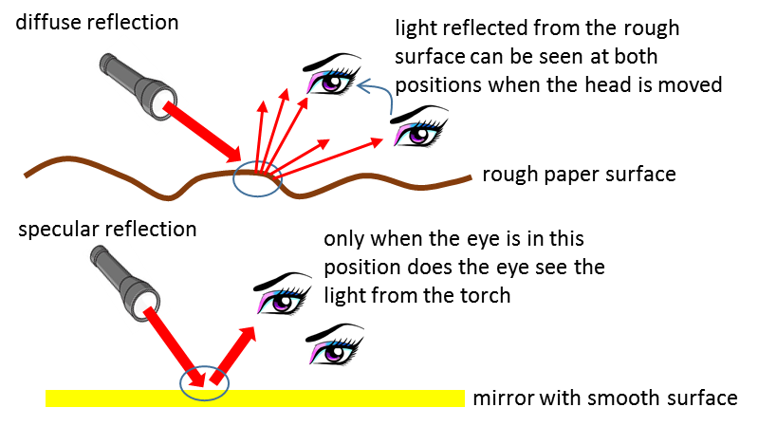

Fig. 8. Reflection of the torch light from a piece of paper and a mirror.

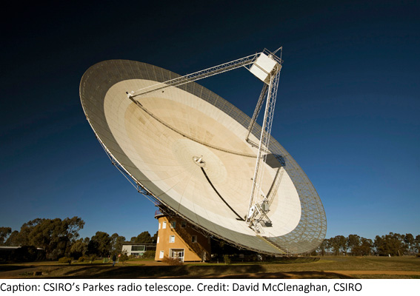Th open mesh parabolic dish of a radio telescope is like a diffuse reflector for short wavelength light but acts like a highly polished reflector for long wavelength radio waves.

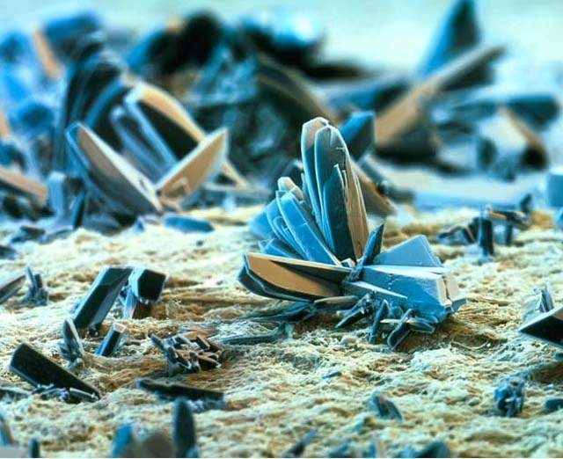

At a microscopic level, paper has rough surface and is a diffuse reflector. The picture shows a magnified view of the surface of a sample of paper.

When a narrow beam of light falls on a plane mirror, the light will not reach your eyes unless they are placed in the correct position where the law of reflection is satisfied (figure 8). When you look straight into a mirror, you see what appears to be yourself as well as objects surrounding you. You and the objects appear as if they are in front of you and located behind the mirror. However, what you see in the mirror is called an **image**. The image formed in the mirror has left and right reversed (figure 8).



Fig. 8. A mirror forms an image where left and right are reversed.

The mirror image is called a **virtual image** since the rays of light do not pass through the image location – it merely seems as though the light is coming from the image because our brains interpret any light coming into our eyes as having come in a straight-line path in front of us. You can’t capture a virtual image on a film by placing it where you think the image is located. A **real image** can be recorded on a film placed at the location of the image since the light rays actually pass through the image location.

From each point on an object light is emitted in all directions. Only the light that travels in a direction such that the law of reflection is satisfied will reach the eye from the mirror.

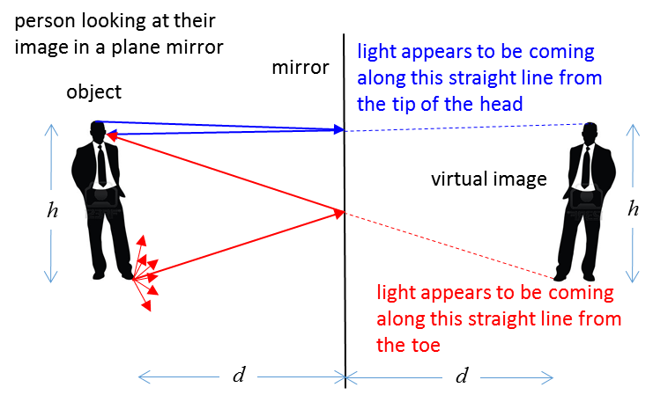

Fig. 9. Formation of a virtual image by a plane mirror. In the reflection of the light rays from the mirror surface, the law of reflection is satisfied (angle of incidence = angle of reflection).

The height *h* of the object and its image are equal. The distance *d* of the object from the mirror and the distance from the mirror to the virtual image are also equal (object distance = image distance). However, the image is reversed – right appears to be left and left appears to be right in image.

**IMAGE FORMATION USING THIN LENSES**

The most important simple optical device is no doubt is the **thin lens**. Lenses are used in eyeglasses, camera, telescopes, microscopes, binoculars, and many specialized optical instruments.

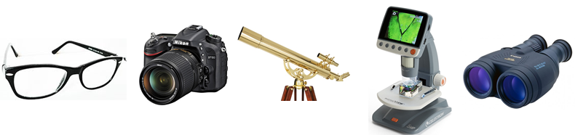

Fig. 10. Optical devises using lenses.

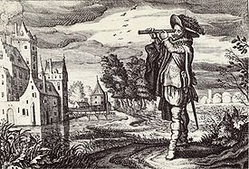Eyeglasses have been used since the late 1200s. The earliest known working telescopes appeared in 1608 in the Netherlands and are credited to Hans Lippershey.

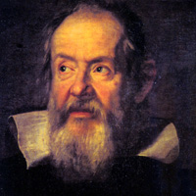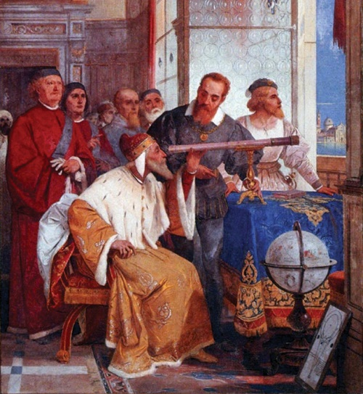[Galileo Galilei](https://en.wikipedia.org/wiki/Galileo_Galilei) (the father of astronomy 1564 - 1642) on 7th January 1610 made a discovery that shook the world and changed mankind's view of our place in the universe. On that evening, about an hour after sunset, Galileo pointed his home-built telescope towards Jupiter, and saw a peculiar sight: two tiny "stars" to the east of Jupiter, and one to the west, all arranged in a tight straight line along the ecliptic path with Jupiter itself. The next evening, almost on a whim, Galileo decided to check Jupiter again just to verify that the three "fixed stars" lay to the east of Jupiter, since he knew that the planet was moving westward against the background stars. Sure enough, there were the three stars again ... but on the west side of Jupiter, not its east! The only explanation was that those stars weren't "fixed" at all, but moved with Jupiter and indeed, seemed to move around it like our own Moon moves around Earth. This was the beginning of the end of the Aristotelian geocentric universe.

A thin lens is usually circular in cross-section and has two faces which are portions of spherical surfaces. Lenses can be classified as **converging** or **diverging** (figure 11). The two faces of thin lenses can be any combination of convex, plane or concave shaped surfaces.

**The important property of lenses is that they form images of objects.**

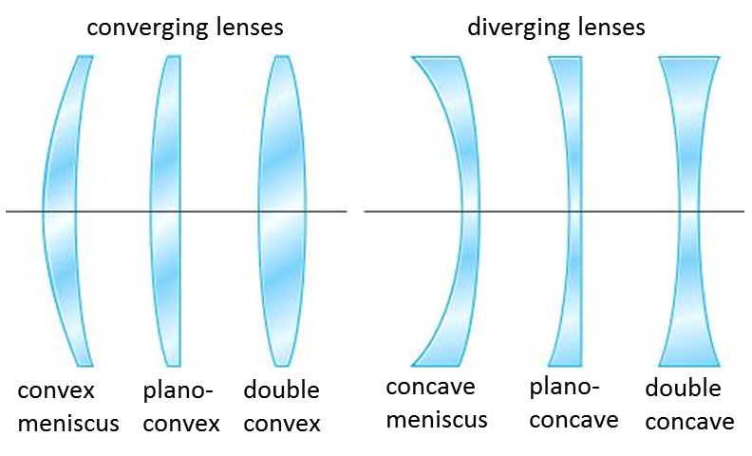

Fig. 11. Different types of converging and diverging lenses.

**Converging thin lens**

A converging lens can be used to focus a parallel beam of light on to a spot on the **focal plane** called a **focal (focus) point** as shown in figure 12. The distance from the axis of the lens to the focal plane is called the **focal length** *f* of the lens.

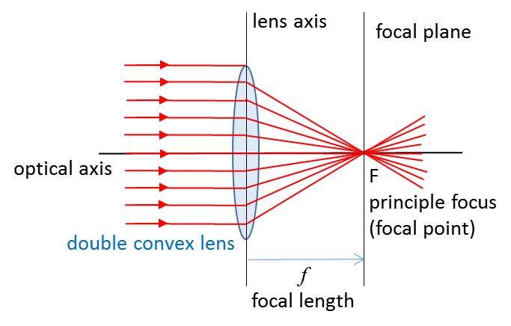

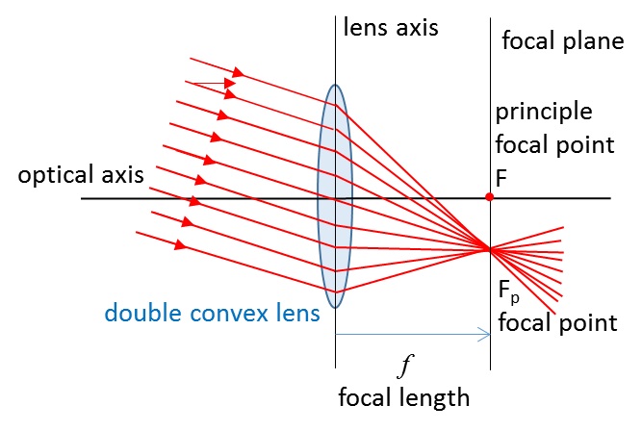

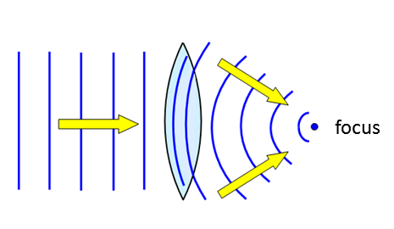

Fig. 12. Rays parallel to the optical axis are focused at a point called the principle focus or principle focal point. Other sets of parallel rays are bought to a focus along the focal plane. N.B. The ray through the centre of the lens does not deviate.

It is easy to find the location of an image of an object for a converging lens using a ray tracing diagram. Select two points on the object – the top and bottom. Only two rays are necessary from each point to give the image location, but the three most useful rays often used are:

1. A ray drawn parallel to the optical axis from the object will be deviated by the lens so it passes through the principle focal point in the focal plane.
2. A ray drawn from the object passing through the centre of the lens has zero deviation.
3. A ray drawn from the object through the principle focal point on the object side of the lens will emerge from the lens parallel to the optical axis.

The intersection of these three lines in the object plane will determine the location and characteristics of the image.

The lens equation for thin lenses relates the focal length  to the object distance  and the image distance 

(2)  lens equation (thin lens)

If the height of the object is  and the height of the image is , the lateral magnification  is

(3) 

**Sign Conventions**

* Converging lens 
* Diverging lens 
* Object on side of lens light is coming from 
* Image on the opposite of the lens from where the light is coming 
* Image on the same of the lens from where the light is coming 
* Object upright 
* Image upright 
* Image inverted 

Figure 13 show the three rays drawn from the object (tree) to locate the position of the image from the top and from the bottom of the object. The measurements for distances from figure 13 are:



From the lens equation (equation 2) the predicted image distance  is



The lateral magnification  (equation 3)

 image is inverted

The predicted height  of the image (equation 3) is



image is inverted

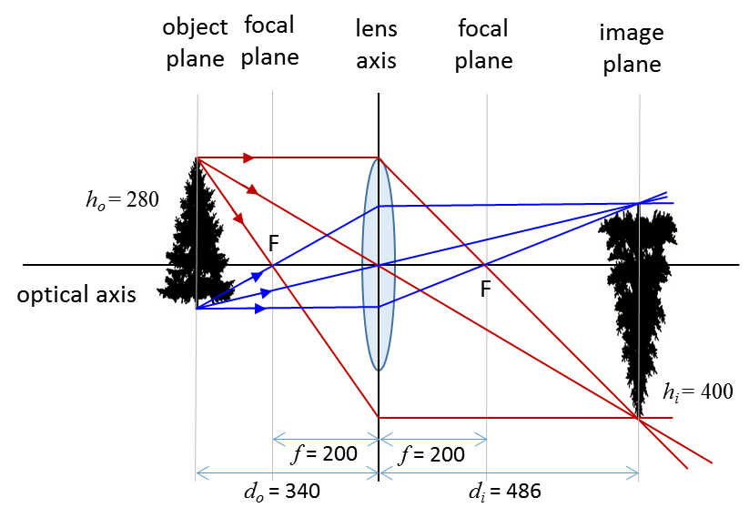

Fig. 14. Ray tracing can be used to estimate the location of the image of an object.

Object placed within the focal length of the lens 

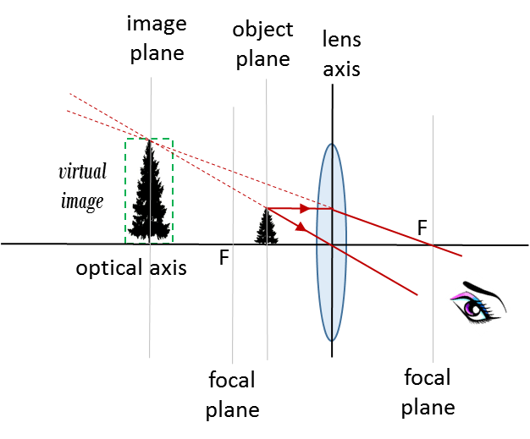

Fig. 15. **Simple magnifying glass** - object placed within the focal length of a converging lens produces a virtual, upright and magnified image.



Using equations 2 and 3 and the above inequalities

  

  virtual image

  upright image

  image height greater than object height

Object placed at the focus of the lens 

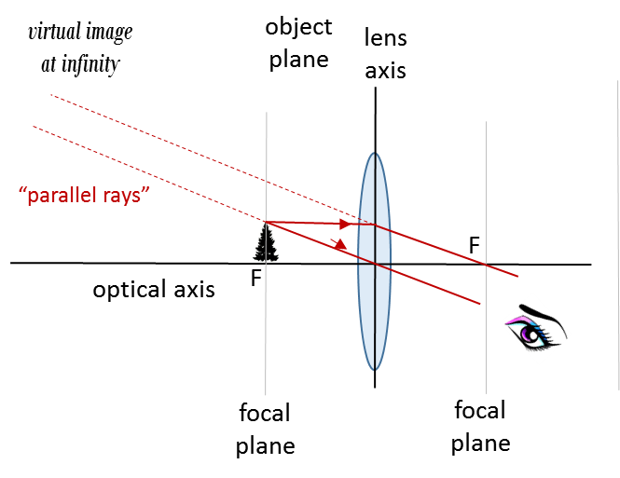

Fig. 16. Object placed in the focal plane. The virtual image is at infinity.



Using equations 2 and 3 and the above inequalities

  

   virtual image at infinity

  upright image and infinite in height

Object placed at the focus of the lens 

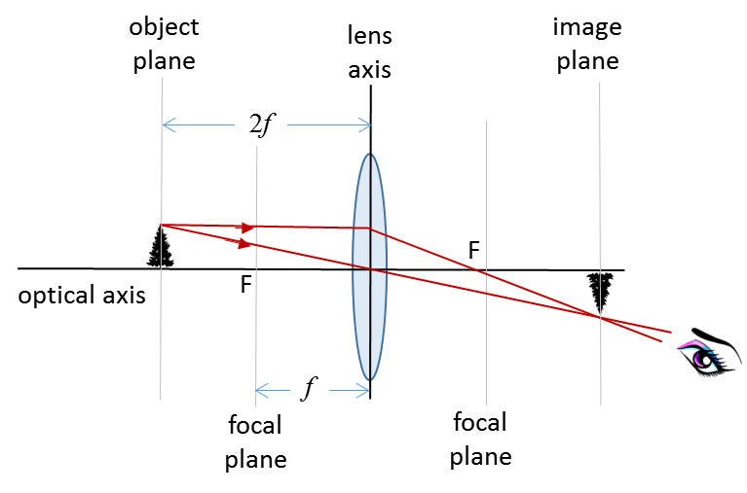

Fig. 17. The object distance is equal to than twice the focal length . The image is real, inverted and same height as object, magnification .



Using equations 2 and 3 with 

  

  real image

  inverted mage

  image height equal to object height

Object at 

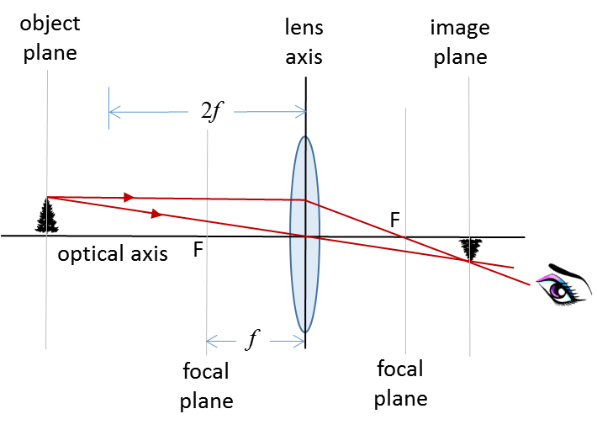

Fig. 18. The object distance is greater than twice the focal length . The image is real, inverted and reduced in height, magnification .



Using equations 2 and 3 with 

  

  real image

  inverted mage

  image height less than to object height

**Diverging Thin Lens**

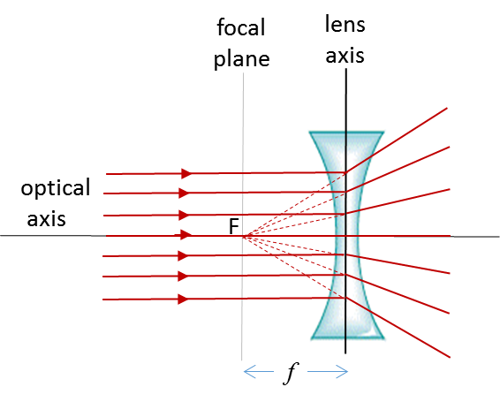

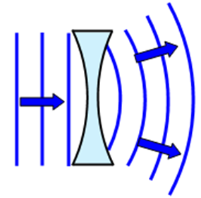

Fig. 19. Diverging lens.

A diverging lens produces a virtual image since the rays of light do not pass through the image.

N.B. The eye does not distinguish between real and virtual images – both are visible.

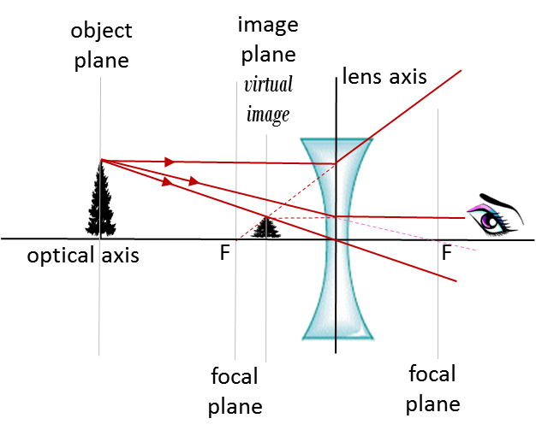

Fig. 19. A virtual image is formed by a diverging lens. the image is reduced in height and upright.

The bright and dark patterns that seem to move across bottom of a swimming pool are a result of the surface of the water acting like a blanket of undulating lenses.

Why stars twinkle has a similar explanation - the irregularities in the atmosphere produces the twinkling.

|  |
| --- |
| **Thinking Exercise Telescope**  Study the ray tracing diagram of the telescope shown in figure 20. Write a careful explanation of how the telescope produces a magnified virtual image of the object.    Fig. 20. Refracting telescope. |

|  |
| --- |
| **Thinking Exercise Compound Microscope**  Study the ray tracing diagram of the microscope shown in figure 21. Write a careful explanation of how the microscope produces a magnified virtual image of the object.    Fig. 21. Compound microscope. |

**Magnificent magnified images**

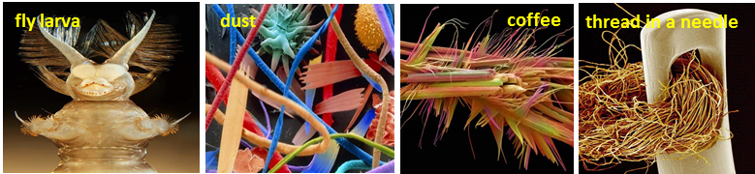

|  |
| --- |
| **Computer simulation activity**  Use the computer simulation to review your understanding of the formation of images using a converging lens or a diverging lens.  Check the numbers displayed in the simulation using the equations:  (2)  lens equation (thin lens)  (3)  lateral magnification  [Lens simulation](http://ophysics.com/l13.html)  You can only change the position of the focal point. |

Please email any comments or suggestions to:

Ian Cooper

School of Physics, University of Sydney

ian.cooper@sydney.edu.au